Critical Design Review
Sandia Clinic

Chris Chadwick
Eric Hsu
Michael Stevens
Rashin Bolkameh
Dan Rolfe
Professor Charles
Introduction

The Global Positioning System (GPS) is a fully functional Global Navigation Satellite System (GNSS). It uses dozens of satellites that transmit microwave signals and enable receivers to determine their current location. The satellites continuously transmit the time, a precise orbit for the satellite sending the message, the general system health and the rough orbits of all the GPS satellites. The receivers then use this information to calculate their position. In order to calculate the current position, the receiver must obtain a signal from at least four satellites. Four satellite signals are necessary to calculate latitude, longitude, altitude, and to account for any time variance in the receiver.

The goal of this project is to build low-power device, utilizing a GPS Front-End Module on the Sandia stack, capture and store that data, and transfer it to the PC via serial.

Because the stack is powered by two CR2 batteries and it should operate for several weeks, a major concern of the project is to minimize the power consumption. There are several ways that power consumption will be significantly lower than a personal GPS receiver. Most GPS receivers require a full signal from the satellites (about 30-40s), one goal of this project is to calculate the position with less than one second of data. This can be accomplished by accessing a database of GPS information knowing the exact time that the signal was sent. Another way the power consumption is lowered is to use an accelerometer to only activate the receiver when the chip is moving.
Expected Timeline of Completion

Task | Tentative Completion Date
Board Design | Jan 26, 2008
Program Microcontroller | Feb 2, 2009
Testing | February 28, 2009
Project Completion | March 6, 2009
Report and Presentation | March 26, 2009
Table 1 expected schedule of events

Design Decisions

Phase 1 hardware diagram
Phase 1:
GPS Front-End Receiver Module - Rakon GRM8650 or SiGe SE4120L
Antenna GPS Chip-Scale
Flash Memory 2GB
Accelerometer ADXL330
uProcessor TI-MSP430
Mini-USB Connection
Geotate or MATLAB to process data then Google Earth to plot coordinates

The First phase of design was based on using a GPS front end receiver module to capture GPS signal to flash memory utilizing a micro processor. Once the data is saved into the flash, we would then use USB to process the data using Geotate or MATLAB.

Problems: USB controller was very complicated to implement, decision on saving 600MB or 128KB of data, GPS data saving issues.

Phase 2 hardware diagram

Phase 2:
GPS Front-End Receiver Module - Rakon GRM8650 or SiGe SE4120L
Antenna GPS Chip-Scale
uSD Flash Memory
Accelerometer ADXL330
uProcessor TI-MSP430
Geotate or MATLAB to process data then Google Earth to plot coordinates

In the second phase, we made the decision of just acquiring 128KB of GPS data versus 600MB. Since the USB controller was hard to implement, we switched to micro SD flash memory interface.

Problems: Large amount of data requires faster and stronger micro processor which defeats the use of low power micro processor. Micro SD interface is not open source information.

Phase 3 hardware diagram
Phase 3:
Antenna GPS Chip-Scale
GPS Front-End SiGe SE4120L
Accelerometer ADXL330
uProcessor TI-MSP430
Serial Flash Memory
Serial Output

In the third phase we switch the flash memory to serial flash since flash memory writes in BLOCK and serial flash accepts data in SPI which the micro processor uses. Since we switch to acquiring 128KB of data, MATLAB could not process the data. Geotate Software Company was not willing to help us unless there were a business transaction between them and us. For our project, we decided that the software processing of the data was too complicated for the timeline.

Hardware Design and Layout

Summary of Components

Microcontroller | Texas Instrument (msp430f169)
GPS | SE4120L
Antenna | 1575AT43A40E
Accelerometer | ADXL330
Power Supply | LM2936
Connecter Receptacle | DF12-20DS-0.5V (86)
Connecter Header | DF12 (5.0)-20DP-0.5V (86)
Crystal Oscillator | ASVTX-11-A-16.368MHZ-T
Multiplexor | Fairchild 74AC257
Serial Flash | M25P128
Connector JTAG | FH12A-10S—0.5SH(55)
Table 2 summary of components

Rationale for Component Choices

The board schematic and layout were drawn with Cadsoft Eagle. However, before being able to construct the schematic, all of the parts had to be chosen. The same TI microcontroller was used that was used last year because it was found to be a suitable low power microcontroller. After that, a GPS front end was chosen. After looking at a few options, the SiGe 4120 was used because of its different operating options and it could be used with the Matlab software if needed. The SiGe chip requires an external crystal oscillator so the ASTX-11 was chosen because it was readily available with the correct operating frequency. Once serial flash memory was finally decided to be used, the M25P128 was selected because it was the largest serial flash memory available. For the accelerometer, the ADXL330 was chosen because of its low power consumption. It was necessary to choose a multiplexor to select what would be written to the memory and when so the 74ACT257 was used. A connector, part number FH12A-10S—0.5SH(55), was also needed to connect to Sandia’s JTAG board. After all those parts were chosen, a power supply was selected based on the current needs. The LM2936 was used with a 50mA output that would be sufficient to power all the necessary components. A complete list of parts used can be found in table 1. After all parts were selected, the schematic could be created in Cadsoft Eagle, this schematic can be seen in figure 1. The layout was then generated from this schematic and can be seen in figure 2.

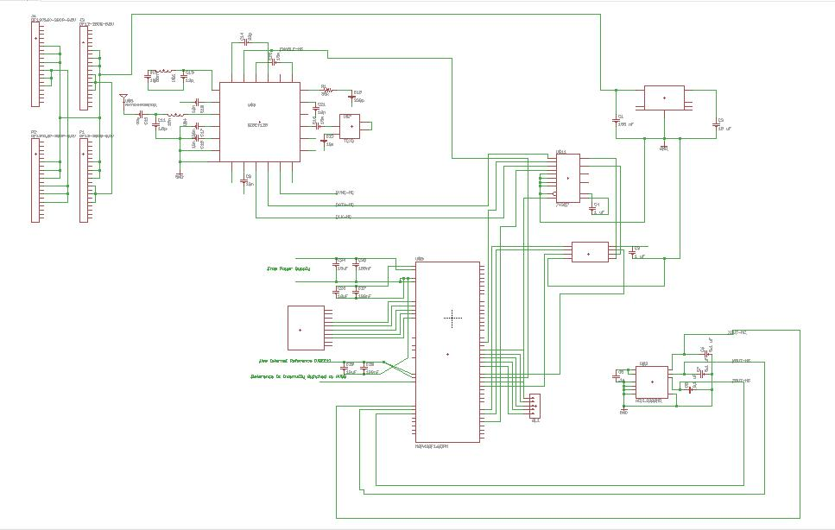
Figure 1
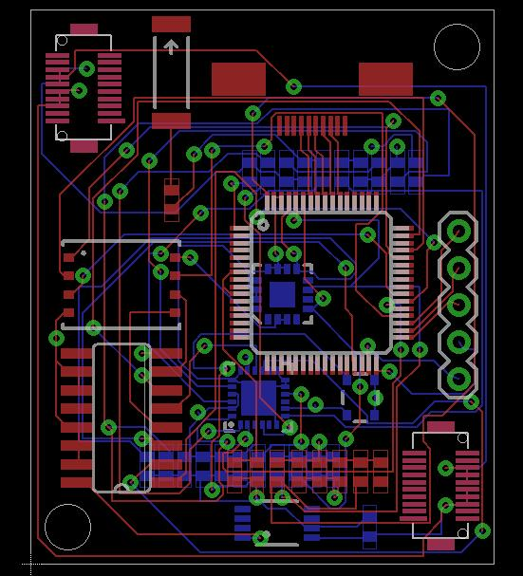
Figure 2
There are some minor changes for the most recent hardware design. Before the changes,? analog signal from the accelerometer is fed into one of the analog to digital converter pins on the micro controller. The analog to digital IO pins do not have the ability to schedule interrupts, this means the micro controller will have to sample at a regular interval. Doing these samples on a constant basis uses too much energy for a low power device. To solve this problem accelerometer information now feeds into comparators, the comparators then feed into the micro controller. The comparators change the analog signal of the accelerometer into a digital signal, which can be used on an input to the micro controller capable of interrupts. The new revision will also include some test points and light emitting diodes to be used in debugging, and some zero ohm resistors. Zero ohm resistors will allow for some minor modifications to the board if a flaw is located.

Overview of the Programming
The algorithm used on the TI MSP430 micro controller allows micro controller to be in power saving mode as long as possible. The main sections of this algorithm include
- Setup
- Low power loop
- Capture a GPS sample
- Transmit samples to outside system

The setup section makes sure the system is initialized properly and ready to enter the low power loop.

The micro controller spends the most time in a sleep-based loop doing as little actual processing as possible. The sleep based loop keeps the micro controller in a power saving state most of the time, saving as much power as possible. When the completed unit is moving, the accelerometer sends a signal to the micro controller. The signal the accelerometer sends to the MSP430 will trigger an interrupt in the software, which will run a new section of code.

When the interrupt is received, the MSP430 is going to prepare to write another GPS sample to the serial flash. The accelerometer signal is received when the hardware begins to move. Although it may be useful to know the system is moving, getting a GPS sample should wait until after it has moved some distance. Using a timed sequence, loop or sleep function provides the time stall between the signal and the sample. After a suitable time stall, the MSP430 will make sure all is ready for the SiGe GPS to write the sample to the flash memory. Another wait keeps the micro controller from interrupting the sample capture process until a sample of suitable size is completed. Once the capture completes, the software returns to the power saving sleep loop.

After the GPS samples are captured, the final portion of code deals with getting the GPS samples off of the memory and onto another system to be processed.
For a basic view at program execution see figure 3.
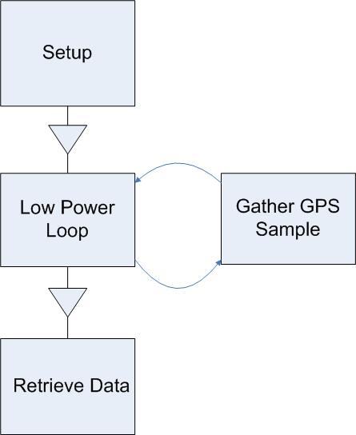

Figure 3
Program execution will start with some simple setup. The program will move into the low power loop. Control will transfer between the loop and getting a GPS sample. Once the samples have been captured, data retrieval will be possible.

So far the only code complete is some setup, the simple skeleton for the low-power loop and the gather GPS sample portions. These were coded using only the development board for the micro controller. Once the loop and interrupt is demonstrated, working the code will be modified to include the actual hardware needed.

Some Thoughts for the Programming
We are planning to have the first revision of the code done by February 2nd, but so far progress has been slow. So far most efforts have been spent writing the algorithm to get the GPS samples onto the flash memory. Until writing to the memory seems to be working little time will utilized thinking about how to get GPS samples off of the flash.

The flash memory will also need to be erased before use due to how it actually writes. When the memory writes, it does not copy all of the information given. Erasing the memory sets all of the bits, then to write the memory will only flip bits that do not match. Placing the erase in the code will have to be done carefully to avoid accidentally erasing wanted data.

Risks and Concerns

As the group has progressed, the concerns have changed. At this point our main concerns are, programming of the micro controller, testing, retrieval of data, and time. The first concern is programming of the micro controller. This will be the main focus of the group while the board is off at fabrication. This way once the board is back from fabrication, testing can begin.

The group biggest concern of the group is testing the board. In testing the board the group will have to identify any problems and diagnose any problems. Once the problems are known the group will have to identify if the problems is a programming or hardware problem. This must be done in a timely manner that way if there is any hardware problem that can’t be resolved a new board can be designed and tested. Another concern is part of testing, the retrieval of data, specifically the serial interface with the computer. This is the part of the project with the most unknowns.

The last concern is time management. With the technical open house approaching time managements is more important than ever. The group must strictly stick to the time line that the group has set.

There is also some risk involved with finishing the project. The biggest risk is the ability to get the board work in a timely manner. To minimize this, the group will have to spend a much time as need on the project to maintain the schedule.

